Module 1 Basic Knowledge

  - International Program

International Program Business (IPB) provides insurance solutions for customers that have headquarters in the country and have operations that require insurance protection in more than one other country.

An International program is the insurance solution that provides cover for such a Customer.

The initial contract between the customer and the Zurich is normally in the country where the customer has its headquarters.

This Zurich office will, in most cases, issue a Master contract….

In addition, this office will involve other Zurich offices in the countries where the customer is active and wants cover provided in the International Program.

In addition, this office will involve other Zurich offices in the countries where the customer is active and wants cover provided in the International Program by requesting them to issue local contracts.

For countries where there is no Zurich office, a Partner company will be requested to provide services to the customer in that country.

There are two types of partners: those working directly in IPS (also known as Direct Partners) and those working through a Zurich hub office.

An International Program is the combined coordinated insurance cover in Liability, Motor, Property, Technical lines and/or Marine provided by issuance of a Master contract and local contracts.

The Master contract usually provides a broader scope of cover then the individual local contracts.

The Local Contract provide coverage as close as possible to the master contract, taking into account the local customs, limitations, laws and regulations.

To close the potential gap between the coverage and limits provided by the local contracts and the master contract, the Master includes DIC and DIL coverage.

DIC stands for Difference In Conditions.
DIL stands for Difference In Limits.

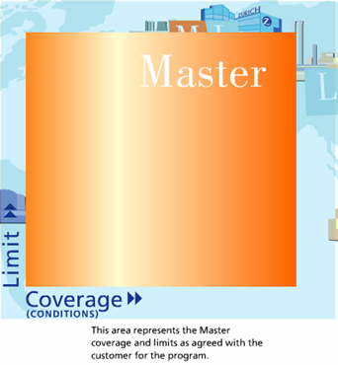 | 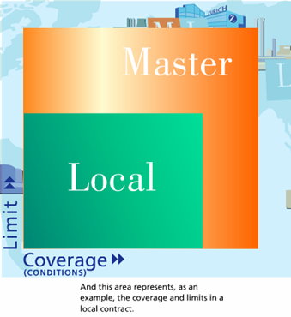
This area represents the Master coverage and limits as agreed with the customer for the program. | This area represents, as an example, the coverage and limits in a local contract.

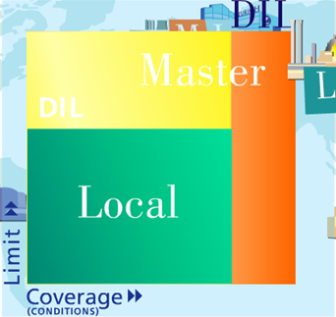
DIC coverage takes care of the gap in coverage between that provided by the local contracts and that provided by the Master, for the full limit of the Master.

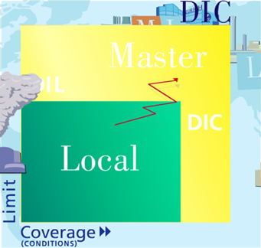

DIC coverage takes care of the gap in coverage between that provided by the local contracts and that provided by the Master, for the full limit of the Master.

So if a loss is not covered by the local contract, the Master contract, with its broader coverage, will pay the claim (provided the loss is covered in the first place)

The Zurich office that coordinates the activities within the International Program and has the primary contact with the customer is called the Producing Country or, in short PC.

The Zurich offices or Partner companies that issue the local contracts are called Receiving Countries or, in short, RC

One Zurich office can be both a PC, for its own produced programs, and can RC, issuing local contracts for programs produced by other PCs.

1.2 Money flow within a Program

This lesson provides an overview of the reinsurance setup within an international program regardless of where the program is produced. It also illustrates the reinsurance setup and money transfers for International Programs produced by the UK, North America, Latin America, Asia/Pacific and ZI-Switzerland. It highlights the movement of premium and claims between the RC and PC, as well as between the PC and any external reinsurers / captives. This lesson also includes the introduction of ALORA.

Premiums are collected for an International Program in the countries where local contracts are issued. Moving these premiums back to the Producing Country, where they can then be ceded to either a reinsurance panel or an insured's captive, is an important component of Zurich's value proposition to the global corporate customer.

The premium is moved via internal reinsurance cessions from the RC to the PC. Usually 100% of the local risk and premium is ceded to the PC, unless there is a mandatory retention required by the local government.

For any portion of the local risk and premium retained in the RC, the RC is responsible for the reinsurance of that retained part.

The PC is responsible for purchasing reinsurance for the program, including any cessions from the local contracts.

The risk transfer to the reinsurance panel or the insured's captive limits the PC's liability for the whole international program.
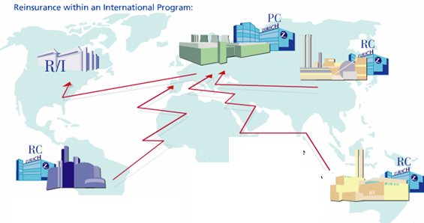
Note that

In certain countries, there is a mandatory cession to the state reinsurer.

In a few countries, laws require that all premium and risk must be retained locally.

The PC and RC can agree that, do to the small premium amounts and risks premium and risk local (i.e. on an own account basis).

The Operating Directives stipulate a minimum premium for local contracts of USD 1500 or equivalent in local currency.

if both the RC company and the PC company are branch offices with in the Zurich group, for legal reasons, a direct reinsurance cession from the RC to the PC is not allowed.

Where a direct cession is not allowed, the premium and claims cessions must go through ALORA. ALORA is an acronym that stands for All Lines Open Reinsurance Agreement.

ALORA is an internal insurance vehicle that allows one branch office to reinsure another branch office.

To illustrate for a premium cession, the RC cedes to ALORA and ALORA cedes to the PC without retaining anything.

In addition to the branch to branch cession, certain RCs always require an ALORA cession.

There are several companies used for handling ALORA cession. The company used is dependent on the RC involved.

IPS is programmed to automatically determine and use the correct ALORA Company once the RC and PC are identified in the system.

Money flow within an International Program (Premium)

For premiums in an international program, the local customer is invoiced by the local Zurich or partner office, the local customer pays the premium to the RCs. Likewise, when the primary customers invoiced by the PC for the Master and any local PC contracts, the primary customer pays the premium for those contracts to the PC.

The RC then cedes the premium to the PC, taking into account the agreed cession percent (usually the cession is 100%)

The PC, in turn, cedes to its reinsurers or the insured's captive.

Money flow within an International Program (Claims)

For claims belonging to an international program, the RC handles the claim, pays the indemnity to the local customer and records the indemnity and expense payments in their local system.

The PC, as reinsurer, reimburses the RC for the indemnity and expense payments in the next monthly settlement with the RC.

The PC then bills and recovers claim payments from its reinsurers or the insured's captive.

Money flow within a Program of a CEC Program Leader

This lesson illustrates the unique reinsurance setup and money transfers for International Programs produced by the Zurich offices in Europe (other than the UK and ZI-Switzerland). It highlights the movement of premium and claims between the RC and the CEC Clearing House, as well as between the CEC Clearing House and any external reinsurers/captives. This lesson also includes the introduction of ALORA.

The Program Leaders within CEC individually produce their International Programs and issue the Master contracts and local PC contracts for customers in their country.

However, for all CEC-produced programs, the CEC Center is considered the PC and will:

- Centrally coordinate the program Reinsurance;
- Act as a Reinsurer of the RCs for the specified cessions; and
- Act as Reinsurer of the program leader for 100% of the Master and any local PC contracts.
- Note that the CEC Clearing House is an organizational unit within the CEC center that acts as the accounting center of CEC.

Reinsurance within a CEC-Produced program
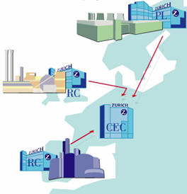
The RCs local risk and premium is ceded directly to the CEC Clearing House. Usually 100% of the local risk and premium is ceded, unless there is a mandatory retention required by the local government.

Also, 100% of the risk and premium for the Master and any local PC contracts of the Program Leader is ceded to the CEC Clearing House.

The CEC center centrally arranges reinsurance for all CEC programs including the ceded part of the local contracts.

The risk transfer to the reinsurance panel or the insured's captive limits the CEC's liability for the whole international program.

Note that:
- In certain countries, there is a mandatory cession to the state reinsurer.

- In a few countries, law requires that all premium and risk must be retained locally.

- The Program Leader and the RC can agree, that, due to the small premium amounts(and risks) involved, the RC will keep 100% of the premium and risk locally(i.e. on an own account basis). The Operating Directives stipulate a minimum premium for local contracts of USD 1500 or equalent in local currency.

Introduction to ALORA

The CEC Center is licensed as a branch office of Zurich Insurance Company. If the RC is also a branch office within the Zurich group, for legal reasons, it is not permitted to have a direct cession from the RC to the CEC Center.

Where a direct cession is not allowed, the premium and claims cessions must go through ALORA. ALORA is an acronym that stands for: All Lines Open Reinsurance Agreement.

ALORA is an internal reinsurance vehicle that allows one branch office to reinsure another branch office.
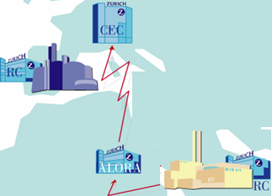
To illustrate for a premium cession, the RC (or the Program Leader) cedes to ALORA and ALORA cedes to the CEC Clearing House without retaining anything.

In addition to the branch cession, certain RCs always require an ALORA cession.

There are several companies used for handling ALORA cessions. The company used is dependent on the RC involved.

IPS is programmed to automatically determine and use the correct ALORA Company once the RC and Program Leader/CEC Center are identified in the system.

Money flow within a Program of a CEC Program Leader

Money flow of within an International Program (Premium)

For premiums in a CEC-Produced program as follows

Once the local customer is invoiced by the local Zurich or partner office, the local customer pays the premium to the RC. Likewise, when the primary customer is invoiced by the Program Leader for the Master and any local PC contracts, the primary customer pays the premium for those contracts to the Program Leader.

The RC then cedes the premium to the CEC Clearing House, taking into account the agreed cession percent (usually the cession is 100%). The Program Leader also cedes the Master and local PC contract premiums.

The CEC Clearing House, in turn, cedes to its reinsurers or the insured's captive.

Money flow of within an International Program (Claims)

For claims belonging to a CEC-Produced program as follows
The RC handles the claim, pays the indemnity to the local customer and records the indemnity and expense payments in their local system.

The CEC Center, as reinsurer, reimburses the RC for the indemnity and expense payments in the next monthly settlement with the RC. The CEC Center also reimburses the Program Leader for the Master and local PC contract claims.
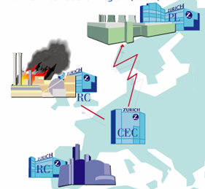
The CEC Clearing House then bills and recovers claim payments from the reinsurers or the insured's captive.

Note: For DIC/DIL claims covered by the Program Leader's Master, the CEC Clearing House reimburses both the RC, for payments made locally on behalf of the Program Leader, and he Program Leader for that portion of the claim covered under the Master contract.

1.3 PC and RC tasks (regarding program business and within IPS)

1.3.1 Tasks of the PC
International Program Business is negotiated and agreed with the customer and/or broker in the Producing Country. As such, the PC is responsible for ensuring that the Zurich and the partner network delivers the risk transfer and administration services agreed upon at the time of binding.
Tasks of the PC
This responsibility translates into the following tasks for the PC:
- To negotiate program with the customer and/or broker

- To develop and enhance the overall relationship with the customer, in conjunction with Strategic Relationship management, where appropriate

- To issue the invoice for the master and the local PC contracts

- To issue master and the local PC contracts

- To communicate and coordinate local contract and invoice issuance with the RCs

- To monitor the information and money flow according to the timeframes stipulated in the Operation Directives, customer service level agreements and/or reinsurance agreements, escalation issues when necessary

- To collect the premium for the master and the local PC contracts

- To handle claims rising from the policies issued in the PC country

- To coordinate DIC/DIL claims

- To arrange reinsurance for the program; and

- To provide reports to the customer as requested

The previous tasks may involve the use of IPS. As such, the tasks of the PC related to IPS are:

- To give complete details to the RCs so the local contract can be issued, while adhering to the timeframes stipulated in the Operation Directives

- To enter the details of the Master and the local PC contracts

- To enter premiums and claims for the Master and local PC contracts

- To generate reports for the customer and

- To monitor the policy issuance, invoice issuance, premium collection and money flow for the program using the monitoring reports in IPS reporting

- Note that the reinsurance arranged by the PC for the program is not administered in IPS, however the Reinsurance structure can be reflected on a Program level for information purposes.

1.3.2 Tasks of the RC

While the PC is responsible for the negotiation and ultimate agreement with the customer, the Receiving Country plays an equally important role in delivering on the risk transfer and administration services for that customer.

Tasks of the RC
This responsibility translates into the following tasks for the RC:

- To issue local contracts for programs coordinated in other countries

- To issue invoices for local contracts

- To collect the local premiums and notify the PC that the premium has been received, if requested

- To handle the claims arising from the local contracts

- To handle DIC/DIL claims on behalf of the PC

- To report cessions and claims to the PC or the CEC Clearing House monthly

- To arrange monthly money transfers with the PC or the CEC Clearing House for the cessions and claims

- To provide reports to the local customers and authorities; and

- To monitor and adhere to the timeframes for information and money flow stipulated in the Operating Directives, escalating issues when necessary

The previous tasks will likely involve the use of IPS. As such, the tasks of the RC related to IPS are:

- To supplement the local contract data entered by the PC with information received locally

- To enter premium bookings

- To enter claims including the claim bookings

- To crate Premium Paid Advices(if requested) advising the PC when premium has been received locally

- To produce cession and claims reports to the PC or the CEC Clearing House monthly;

- To generate monthly financial settlements to the PC or the CEC Clearing House; and

- To monitor the policy issuance, invoice issuance, premium collection and money transfer for all received contracts using the monitoring reports in IPS reporting.

1.4 The Zurich Organization

An interactive World map explains the different types of Zurich offices in the Zurich network of companies and the Partner companies both direct and via Hubs.

Subsidiaries:
In these countries, program business is, for the most part, written by a wholly-owned or majority owned subsidiary of Zurich Insurance Company. These companies are licensed as separate entities in the countries in which they operate. (Note that some countries have both a Subsidiary company and a Branch Office.)

Branch Offices:
In these countries, Zurich has a Branch Office writing the program business. A Branch office is an operating extension of Zurich Insurance corporate center in Zurich, Switzerland.

This means that Zurich Insurance Company has actually obtained a license to operate in these countries. If both the RC and the PC are a Branch office, an ALORA cession is required for cessions between the tow companies. (Note that some countries have both a Subsidiary company and a Branch Office.)

Affiliated Companies:
In these counties Zurich has an affiliated company. An affiliated company is one where Zurich has a minority interest in the company issuing the contracts.

Representations:
In these countries Zurich is only represented.
This means that Zurich has no license to issue contracts, but that the Zurich network is represented to other local carriers.

Partner Companies:
In these countries there is no Zurich Company or office present. However to ensure a broad scope of services for our customers, the Zurich has a partner service agreement (PSA) with a local insurance company to issue local contracts for programs, In addition, the relation ship with that partner is managed by one of Zurich's Hub offices.

Note on the user of our partner companies: In countries where Zurich is not represented, Zurich is focusing on developing relationships with a limited number of external partner companies, These companies have proven track records in the areas of contract issuance, accounting practices and claims handling, and have expressed a willing ness to abide by the Operating Directives.

There are many companies shown in IPS that were used in the past but do not meet the above criteria for an ongoing partnership with Zurich. These 'unauthorized' companies have an asterisk (*) next to their name in the drop down lists in IPS.

If a particular program requires the use of an unauthorized company or the introduction of a new company not currently listed in IPS, PC Underwriting Management(in conjunction with Partner Management in the Corporate Center and the Hub Manager for that region) must:
- Authorize use of the company
- Have the company added to IPS (If not already shown in IPS), and
- Document the reasons for using the company in IPS and the PC underwriting files.

Online Zurich Companies:

The Zurich-owned companies in these countries have a direct connection to IPS.
(Most have an electronic interface to deliver premium and claims data.)

Regional Hubs:
The companies in these countries have a Regional Hub function. This means that they manage the Partner relationship, ensure issuance of local contracts and invoices in partner countries and enter data into IPS on behalf of these partners.

Countries served by a Regional Hub:
For the companies in these countries, a Regional Hub manages the relationship with the partner, including the entry of data into IPS.

Online Partner Companies:
The selected Partner in these countries has a direct connection to IPS.

The IPS World:
All data for these countries is entered into IPS either directly or by a Regional Hub.

Module 2 Structure of the Data

2 Structure of the Data (in IPS)

Introduces how the data is structured (customer, program/template contract, premium booking and claim) and how the data elements relate to one another.
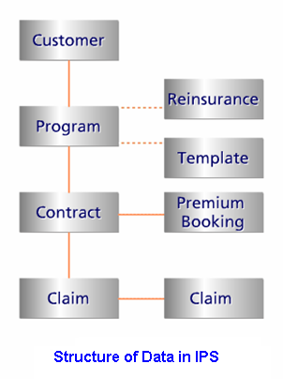

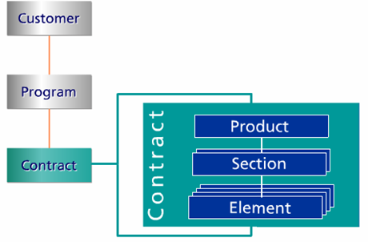
2.1 Customer: The customer is highest level of data in IPS. The customer data elements in IPS are very general and are entered by the Producing Country (PC).

2.2 Program: When a Customer requires coverage for more than one product, multiple programs can be crated in IPS that are linked to that customer. Only the PC can create new programs in IPS.

2.3 Reinsurance: Also at the Program level, the Reinsurance structure can be entered as a basis for the NatCat exposure data. This information will be fed to the ATHENA system. This data is for information purpose only. IPS is not built to handle the Reinsurance administration itself.

2.4 Template: In IPS, contracts are generated using a Template to speed up contract creating for a Program. The data on the template is, for the most part, common to all contracts. The data stored in the Template is used only for the generation of contracts and will not affect reporting. While generating contracts, the stored Template data will be repeated for each new contract. The PC is responsible for completing the template and generating the Contracts.

2.5 Contract:
Within each Program, one or more Contracts exist for each country where local coverage is required. After the Contracts are generated, both the PC and RC update the Contract data.
The Contract screens are the main communication vehicle used to send local contract details between PC and RC. The information in the Contracts is used to measure timeliness of the information flow for the Operating Directives.

2.5.1 Product: Typically, a Contract includes one product (for example, either Property or Motor). There is one exception to this rule, when Property and Technical are combined. In this case, a single contract may contain both products.

Product Structure
PR = Property, TE= Technical, LA = Liability, MA = Marine, MT = Motor
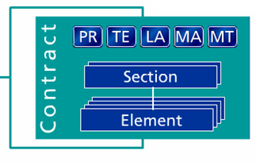
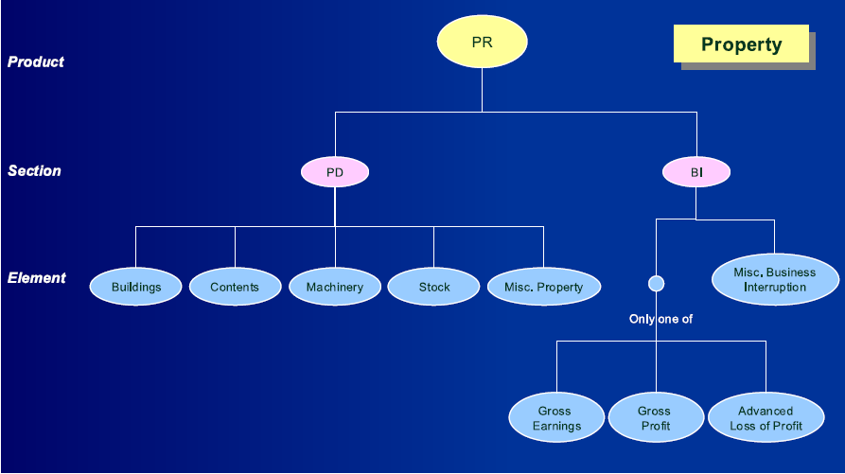
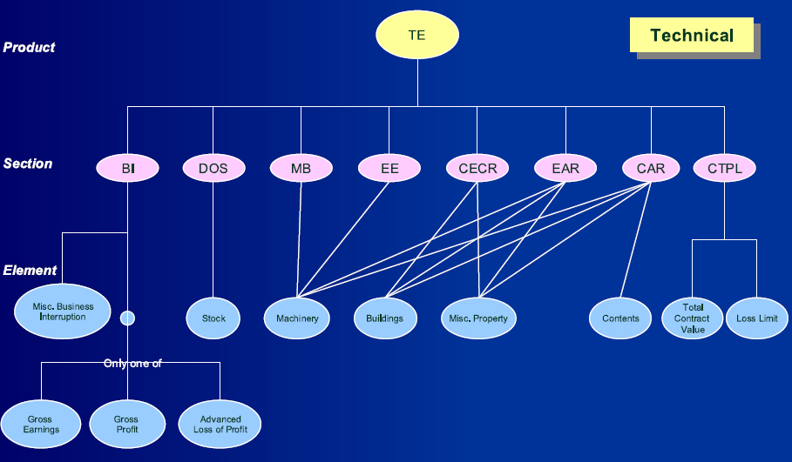

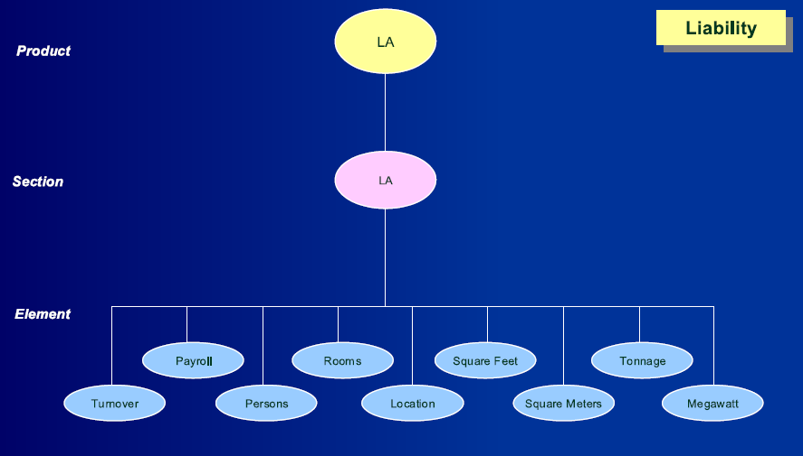
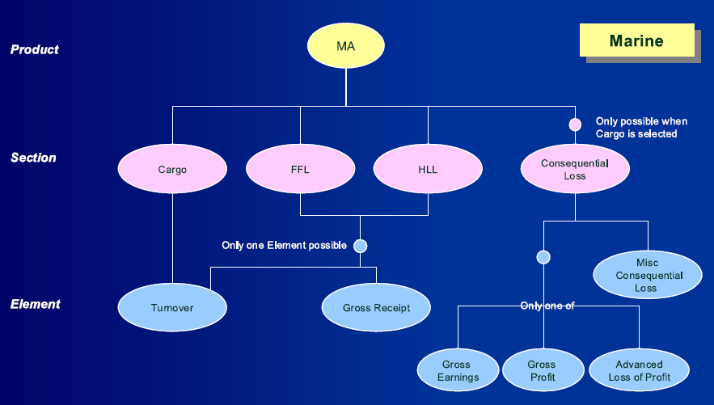
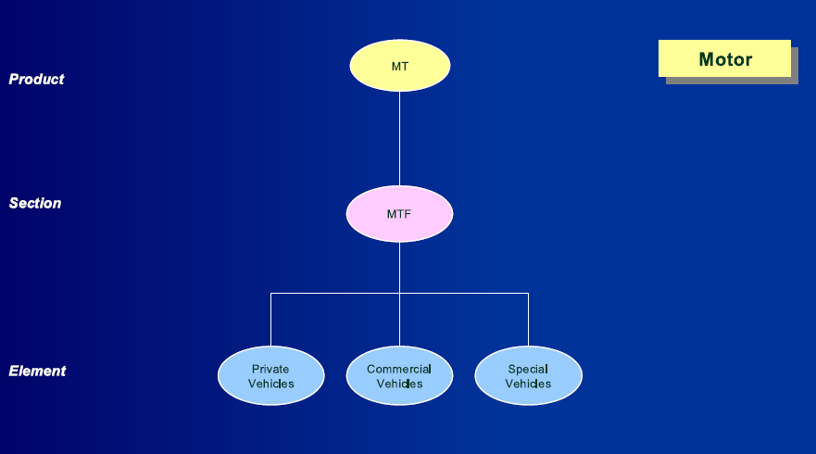

2.5.2 Section: Each Product within a Contract can have one or more sections (for example, Business Interruption and Property Damage on a Property product, or Product liability and General Liability on a Liability product.)

2.5.3 Element: Each section within a product can have one or more elements (for example, building, contents, and stock on a Property Damage section for Property or personal vehicles and commercial vehicles on an Own Damage section for Motor.)

To reduce redundant entry, information in IPS is entered from top to bottom.

- First, for the Customer, enter data that is valid for all programs of that Customer.

- Next, for the Program (including the Program Template), enter data that is valid fro all contracts of the program.

2.5.4 Premium Booking: For each Contract, Premium Bookings are entered to reflect the premium charged locally for that Contract.

The bookings will reflect the premium and any applicable taxes and costs (i.e. premium taxes, brokerage fees and policy issuance costs).

The booking is entered by the Receiving Country that issues the contract. (Note that for Partner Companies, the responsible Zurich hub will enter the premium booking.)

2.5.5 Claim: The Claims reported (and covered) by the local Contract are entered on each IPS Contract by the Receiving Country that issues that local Contract. (Note that for Partner Companies, the responsible Zurich hub will enter the claims).

The majority of Claims entered in IPS are electronically interfaced from the local systems.

2.5.6 Claim Booking: For each Claim, the associated bookings are entered to reflect the most recent financial activity on the Claim. This includes, for example, the applied deductible amount, the current reserves, and any expense or indemnity payments.

The Claim bookings are entered by the Receiving Country that issues the local Contract. (Note that for Partner Companies, the responsible Zurich hub will enter the claim booking).

Module 3 Roles and Functions

3.1 Introduction to Roles and functions (in IPS)

Introduces the roles of the various users of IPS and the basic system functions of create, modify and view.

There are many different roles in IPS. Examples include: PC Underwriter, RC Underwriter, PC Claim Handler, RC Claim Handler, PC Accountant, RC Accountant etc. IPS allows each of these roles to perform the basic functions such as create, modify and view, according to pre-defined authorities.
This lesson identifies some of the roles in IPS and explains how IPS limits the functions for those roles according to those pre-defined authorities.
As a user of IPS, you were assigned at least one role when you were given authority to user the system by your IPS coordinator. Given the job you perform, it is possible that you were assigned more than one role. Your assigned roles(s) are dependant on the tasks you need to perform in IPS.

In addition to being assigned specific roles in IPS, you are also given authority based on the country in which you work and the companies within the country.

It is important to note that some roles have a RC and a PC version (e.g. there is a RC underwriter role and a PC underwriter role.)

There are three basic functions for each data screen:
Create: Enter new data. (Note: This will, in most cases, generate a new IPS ID)
Ex generate a new contract; renew a contract with new period for existing contract id. Register a new claim with new claim ID.

Modify: To change, add or delete data on an existing record.

View: To view existing data.

When accessing screens in IPS, IPS checks if you are authorized to access the data on that screen.

The general rule for accessing data in IPS is that you have to be assigned as a user of either the RC or the PC Company on that record and you have to be assigned an appropriate role to create or edit the data.

Example: Only users of Zurich Company in the UK and a Zurich company in Sweden can access a Swedish RC contract for a program of ZI UK.

In addition to the company, ability to access data in IPS depends on whether you have a RC or a PC role:
An underwriter of Zurich Sweden assigned a PC role cannot access a RC contract of Zurich Sweden.

In addition to the company, ability to access data in IPS depends on weather you have a RC or a PC role:
Only a RC underwriter in Sweden assigned an RC role can perform this task.

In addition to the company, ability to access data in IPS depends on whether you have a RC or a PC role:

An Underwriter of ZI UK assigned an RC role cannot access a claim for a Swedish RC contract. A ZI UK RC underwriter can only access claims registered for RC contracts belonging to ZI UK.

To help you understand those functions which you are allowed to perform on each IPS screen, IPS will inactivate buttons or drop down menu functions and will block entry in fields you are not allowed to change
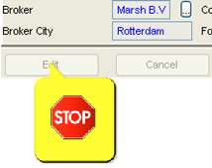
Ex: the Underwriter can view claim information but cannot create or modify it. This happens because IPS does not open claim fields for editing for an IPS user assigned the Underwriter role.
Roles in IPS

Coord PC | UW PC | Premium PC | Claims PC | View
Coord RC | UW RC | Premium RC | Claims RC | Coord ALORA

3.2 What the roles can do (interactive)

Explains which of the basic system functions can be performed by each defined role compared to the structure of the data (e.g. which roles can create the customer).

There is one more factor that could limit the functions you can perform in IPS - the existence of an electronic interface for premium and/or claims data.

You cannot make manual premium and claim entries for those products where you company has a premium and claims interface from the local system to IPS.

Exception: Each country with an interface has at least one user who has special authority to enter both premium and claims data, despite the existence of an interface. Contact your IPS coordinator for further details.

Finally, there is one more role to introduce. To facilitate the creation of the monthly Cession and Claims Lists and the monthly Statements of Account, a special R/I Accountant role has been created. This role is independent of the data structure in IPS, because it works at a company level.

For more detailed overview of the Roles and Functions see the attachment or IPS website.

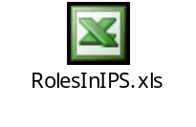

Module 4 Process Overview

4.1 Process Introduction

Shows the basic process of communication, between the PC and the RC, as outlined in the Operating Directives.

4.2 Process contract information

- Explains, in detail, the tasks performed by both the PC and the RC in the communication process on the contract data, including time limits, according to the Operating Directives, RC (or Hub) is online.
- Item, for RC (And/or Hub) is a paper country

4.3 Process of premium/claims

Describes the process for entering premium and claims data into IPS, including time limits, according to the Operating Directives.

4.4 Process of reinsurance and regular money flow (Animation)

Describes the process of regular money transfers between the RC and PC, including time limits, CE/CL and Statement of Account, according to the Operating Directives,

4.5 process of special money flow (Animation)

Describes the process of special money transfers (internal and external cash calls), including PPA, according to the Operating Directives.

Module 5 Log-on to IPS and exit IPS

5.1 Logon to IPS

Explains how to logon to the IPS system.

5.2 Change password

Explains how to change your password in the IPS system.

5.3 Log of from IPS

Explains how to exit or logoff from the IPS system.

Module 6 About the Application

Module 6.1 Windows Specifics

Describes the general screen layout for all screens in IPS.

Module 6.2 IPS Specifics

Explains how to access the drop down lists, the help function, tool tips etc. in IPS.

Module 7 Search and View Data in IPS

7.1 Search
There are three different ways to search for data in IPS.

- Quick Search

- Structured Search

- Advanced Search
    - Quick Search

If you know the unique ID number, enter it in Quick Search and IPS will display the unique result immediately.

    - Structured Search

To search for programs and contracts using the insured name, PC or RC Country, use the structured search. IPS will display a list of records that match the search criteria. Select a record from the list to view the data.

    - Advanced Search

Use the Advanced Search to search for data such as Customer, Program, Contract, Claims or Bookings.

Enter the search criteria manually or select it from the drop-down lists. IPS will tell you if additional criteria is required to perform the search. (You can also view the minimum criteria required by clicking on the right mouse button.)

IPS will display a list of records that match the search criteria. Select a record from the list to view the data.

7.2 View

In IPS each screen allows access to other data through the ‘View‘ on the menu bar. The options in the drop-down menu of ‘View’ are different depending on the screen. These different view options throughout IPS are structured as follows:
7.2.1 List

There are several cases where a list can be viewed for items on the next “lower” level in structure.

These cases are:
Customer: | View Programs List
- Program: | View Contracts List
- Contract: | - View Claims list  - View Bookings list  - View Premium Bookings List  - View Claims Bookings List
- Claim: | View Claims bookings List

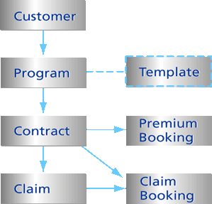

7.2.2. Belonging to
There are several cases where data in the next “higher” level of the structure can be viewed.
These cases are:
Program: | View Customer (and also the template)
- Template: | View Program
- Contract: | View Program
- Premium Booking: | View Contract
- Claim: | View Contract
- Claim booking: | View Claim or Contract
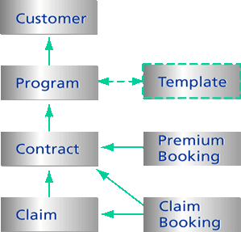

More Information available
……
……
……
……

7.3 Tips
TIP When entering search criteria, you can use the "wildcard" character * so you don't need to enter the complete text you are looking for. It sufficient to enter the beginning letters and/or numbers followed by an "*". For example:

- To search for the customer name 'Global Colours Company', enter "Colo*" in the customer name field of the Advanced Customer Search.
- To search for all programs of the UK: enter "141*" in the Program ID field of the Program Search.

TIP To sort a list of records returned by the search, click on the column header above the column you want sorted.

TIP If you have a question during the entry of search criteria, click the ‘Help’ button.

TIP Here is how to retrieve your data more efficiently, without having to view the customer, program, contract or claim on the search result list. Select a row with the mouse pointer then click on the right mouse button. You can now access the next level list or the advanced search function for the next level entity.

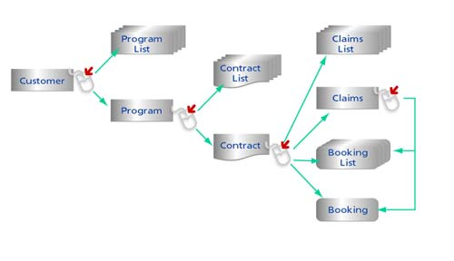

Module 8 How to…

8.1 Customer

Shows how to set up and modify a Customer.
- 8.1.1 Create Customer
- 8.1.2 Modify Customer
- 8.1.3 In/Reactivate Customer
- 8.1.4 Delete Customer

8.2 Program

Shows how to set up and modify a Program.
- 8.2.1 Create a Program
  - A. for PC Coordinator for non-CEC and ZI-CH
  - B. for PC Coordinator for CEC
  - C. for PC UW
- 8.2.2 Modify Program
- 8.2.3 Adjustment
- 8.2.4 Cancel
- 8.2.5 In/Reactivate
- 8.2.6 Transfer
- 8.2.7 Delete

8.3 Template

Shows how to complete and modify a program template.
- 8.3.1 Create Template
- 8.3.2 Modify Template

8.4 Generate Contracts

Shows how to generate and renew contracts.
- 8.4.1 Generate Master Contract
  - A. Single Level
  - B. Multi level
- 8.4.2 Generate Local Contracts
- 8.4.3 Renew Contract
  - A Single Contract
  - B. Multiple Contract

8.5 PC Modify Contract s (complete)

Shows the PC how to complete and modify a contract.
- 8.5.1 Complete Contract Information
- 8.5.2 Modify single Contract
- 8.5.3 Modify multiple Contracts
  - A. Modify Data
  - B. Change Workflow status
- 8.5.4 PR: Allocate Location Values – Spreadsheet
  - A. On-line update
  - B. delete Location
  - C. Insert Location
  - D. Export Spreadsheet
  - E. Import Spreadsheet
- 8.5.5 Splitting of Contracts
- 8.5.6 Copying of Contract

8.6 RC Modify Contracts and PPA

Shows the RC how to modify contracts.
- 8.6.1 Complete Contract Information
- 8.6.2 Modify single contract
- 8.6.3 Splitting of contract
- 8.6.4 Modify multiple Contracts
- 8.6.5 Issue PPA
- 8.5.4 PR: Allocate Location Values – Spreadsheet
  - A. On-line update
  - B. delete Location
  - C. Insert Location
  - D. Export Spreadsheet
  - E. Import Spreadsheet

Module 8.7 Adjustments

Shows how to do adjustments.
- 8.7.1 Create Adjustment
- 8.7.2 Create Multiple Adjustment
- 8.7.3 Create Final Adjustment
- 8.7.4 Change Contract Version Type

Module 8.8 Cancel, in-/reactivate contracts

Shows how to cancel, and in-/reactivate a contract.
- 8.8.1 Cancel contract
  - A. Single Contract
  - B. Multiple Contracts
- 8.8.2 In/Reactivate contract

Module 8.9 Enter Premium Bookings

Shows how to manually enter a premium booking for a contract.
- 8.9.1 Enter Premium Booking
- 8.9.2 Enter Reverse/Correction Booking

Module 8.10 Create/Modify Claims (including bookings)

Shows how to manually enter and modify claims for a contract (including bookings).
- 8.10.1 Create new Claim
- 8.10.2 Add Claim Booking
- 8.10.3 Enter Reverse/Correction Booking
- 8.10.4 Close/Reopen a Claim

Module 8.11 Request Log handling

Shows how to handle the Request Log (special task for interface countries).

  - A. Introduction
  - B. Claims, wrong order
  - C. Claims, edit record
  - D. Premium booking, edit record

Module 9 Reporting

9.1 Standard Reports

Explains the standard reports and how to generate and print them.
- 9.1.1 Contract Information
  - A. View the Contract Order Form (COF)
  - B. View the Contract Print out
- 9.1.2 View the Cession Advice (CA)
- 9.1.3 View the Immediate Claims Advice (ICA)
- 9.1.4 Cession List /Claim List (CE/CL)
  - Submit the CE/CL
  - View the Provisional CE/CL
  - View the Final CE/CL
- 9.1.5 Statement of Account (SOA)
  - Submit the SOA
  - View the Provisional SOA
  - View the Final SOA
- 9.1.6 Search and View Reports in the Report In/Out Box
- 9.1.7 View Functionality in BORP (Same as 9.2.3)
- 9.1.7 Print a Report in BORP (Same as 9.2.4)
- 9.1.8 Save a Report as a PDF File (Same as 9.2.5)

9.2 Ad Hoc Reporting

Explains how to work with Ad Hoc reports in BORP.
- 9.2.1 Logon to BORP for Adhoc Reporting
- 9.2.2 Refresh an Adhoc Report
- 9.2.3 View Functionality in BORP
- 9.2.4 Print a Report in BORP
- 9.2.5 Save a Report as a PDF File

